# **Question 1>**

1. **Create a Login form in login.htm**

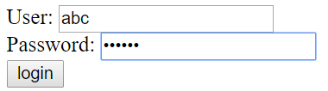

1. **User click login, LoginServlet will be called.**

* It will check {user = abc and password = 12345}
* forward request to WelcomeServlet

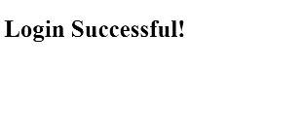

* Else if user enters wrong username or password
* redirect back to login.html
* Note: abc and 12345 must be defined in web.xml as init parameters

# **Question 2>**

1. **Create CalServlet to display**

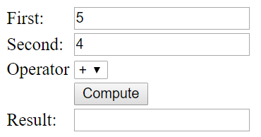

1. **If user click compute, data will be submitted to CalServlet again then the result will be displayed to corresponding textbox**

